# Blooming Deals

Our plants are *growing*, and so we are. Visit our **recently expanded** greenhouses and grounds for hardiest and most beautiful additions to your yard.

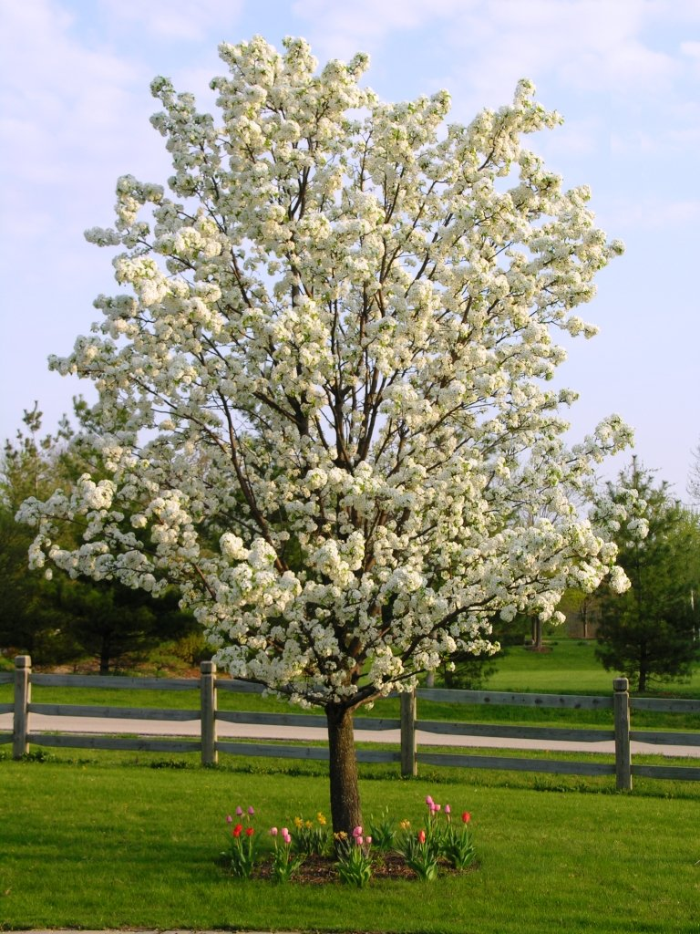

* Wide variety of perennial and annual flowers
* Trees, shrubs, and grasses
* Knowledgeable and experienced staff

## Call Danvers Nursery at 555-8804 today!